### **Superstore Sales Analysis Report**

#### **1. Introduction**

This report summarizes the sales performance of the Superstore, highlighting key trends and insights derived from the data visualization in Power BI. The report covers various aspects of sales, profit, and customer behavior, with a focus on forecasting, regional performance, payment modes, and more.

#### **2. Key Insights from Visualizations**

##### **2.1 Sales Forecast**

* **Objective**: Predict future sales based on historical data trends.
* **Insight**: The forecasted sales provide a projection for strategic decision-making, helping the business prepare for demand fluctuations.

##### **2.2 Sales by State**

* **Visualization**: A map chart displays total sales and profit by state.
* **Insight**: This helps identify high-performing states and regions requiring more attention or resources.

##### **2.3 Payment Modes**

* **Visualization**: Donut chart showing sales distribution across payment modes (Cash on Delivery, Cards, Online).
* **Insight**: Understanding customer preferences in payment methods aids in optimizing payment processing systems.

##### **2.4 Sales by Region**

* **Visualization**: Donut chart depicting sales across South, West, Central, and East regions.
* **Insight**: The South and West regions show higher sales, indicating strong market presence, while Central and East may require targeted marketing efforts.

##### **2.5 Sales by Segment**

* **Visualization**: Donut chart categorizing sales into Home Office, Consumer, and Corporate segments.
* **Insight**: Consumer sales dominate, followed by Corporate and Home Office, suggesting a focus on retail customers.

##### **2.6 Profit and Sales Trends by Month**

* **Visualization**: Area charts for monthly profit and sales.
* **Insight**: Both charts reveal seasonal patterns, with peak sales and profit periods that can guide inventory and promotional planning.

##### **2.7 Sales by Ship Mode**

* **Visualization**: Bar chart analyzing sales performance across different shipping modes.
* **Insight**: Efficient shipping modes (e.g., Second Class, Standard Class) contribute significantly to sales, underscoring the need for logistics optimization.

##### **2.8 Sales by Category**

* **Visualization**: Bar chart showing sales in different product categories.
* **Insight**: The top-performing category helps prioritize inventory and marketing efforts.

##### **2.9 Sales by Sub-Category**

* **Visualization**: Bar chart highlighting detailed performance within sub-categories.
* **Insight**: Specific sub-categories drive overall category sales, offering granular insights for product strategy.

##### **2.10 Performance Metrics**

* **Visualization**: Four KPI cards displaying total orders, total sales, total profit, and average shipping days.
* **Insight**: Quick access to these metrics provides a snapshot of overall business health.

#### **3. Conclusion**

The Power BI dashboard effectively visualizes key sales metrics, offering actionable insights into sales trends, customer preferences, and operational efficiency. These insights are critical for strategic planning, optimizing resource allocation, and enhancing customer satisfaction.

#### **4. Recommendations**

1. **Focus on High-Performing Regions**: Allocate more resources and marketing efforts to high-sales regions while developing strategies to improve performance in lower-sales regions.
2. **Enhance Payment Options**: Ensure smooth functioning of preferred payment modes.
3. **Optimize Inventory for Top Categories and Sub-Categories**: Align inventory management with product performance trends.
4. **Leverage Forecasting**: Use sales forecasts to anticipate demand and adjust operations accordingly.

This report provides a clear overview of Superstore's performance and guides data-driven decisions to boost profitability and operational efficiency.

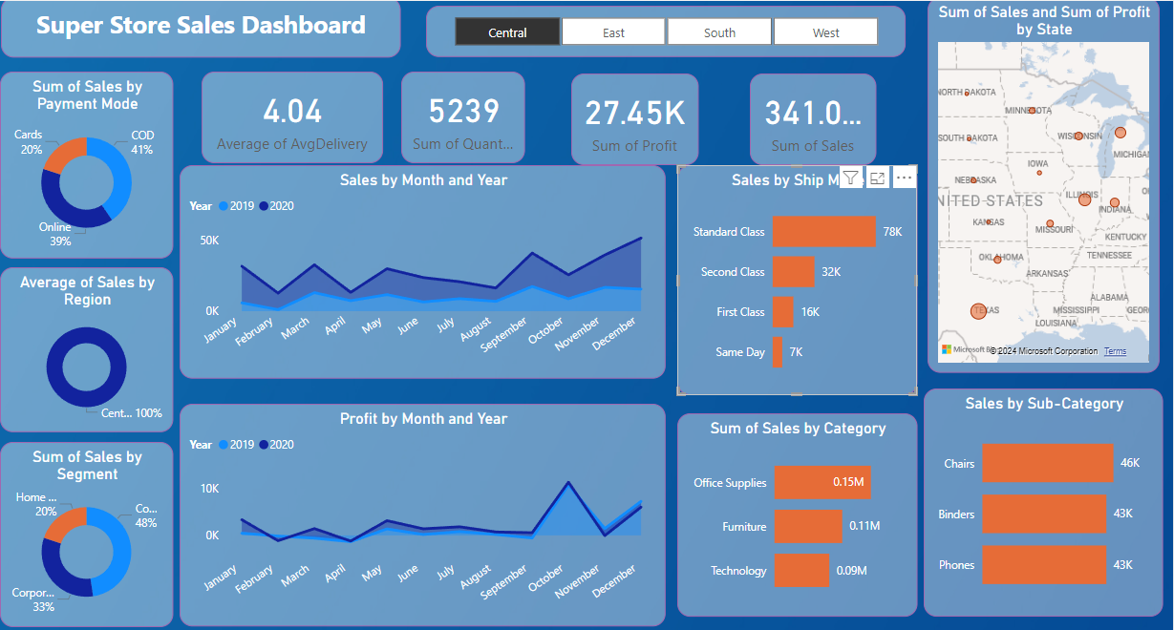

Fig: Dashboard

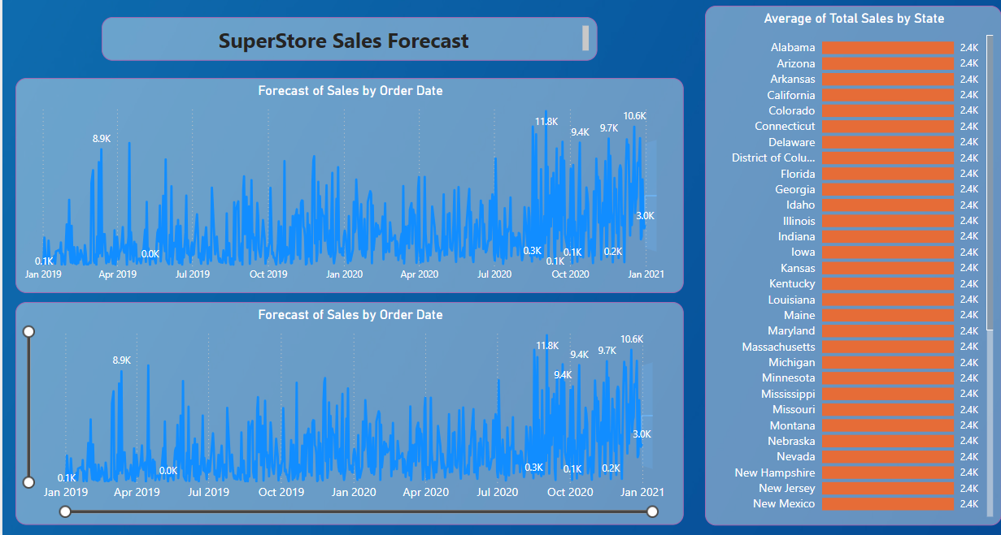

Fig: Forecasting